IT 230 7-2 Final Project Part II

Sean Stiltner Jr.

Professor Sabahudin

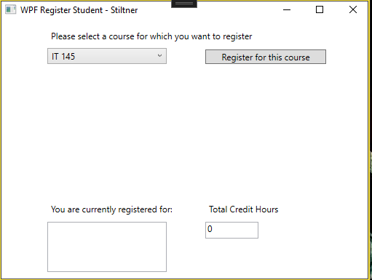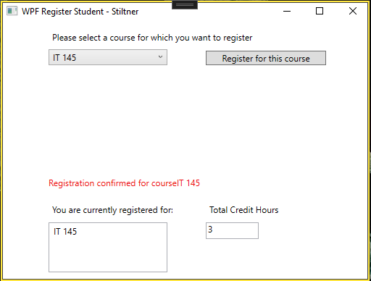

For these two screen shots. This shows that the program is allowing me to select my course and that my first course is worth 3 credit hours.

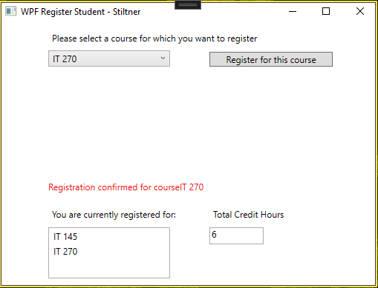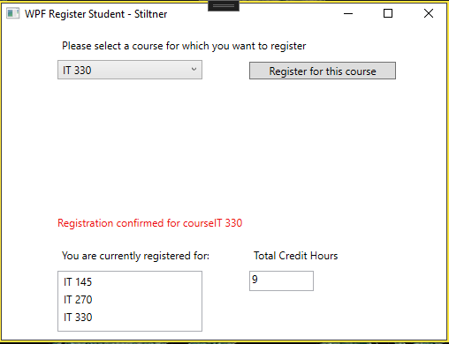

The next two screen shots shows the selection of the 2nd and 3rd course adding 3 credit hours for each course selected.

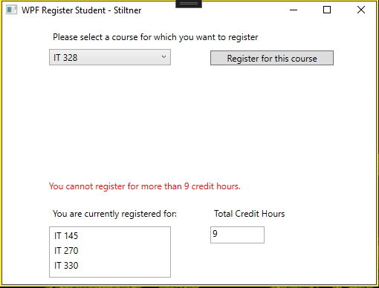

Lastly this screen shot shows that once you have selected your three courses, you cannot register for more than nine credit hours.

Source Code

using System;

using System.Collections.Generic;

using System.Linq;

using System.Text;

using System.Threading.Tasks;

using System.Windows;

using System.Windows.Controls;

using System.Windows.Data;

using System.Windows.Documents;

using System.Windows.Input;

using System.Windows.Media;

using System.Windows.Media.Imaging;

using System.Windows.Navigation;

using System.Windows.Shapes;

namespace WPFRegisterStudent

{

/// <summary>

/// Interaction logic for MainWindow.xaml

/// </summary>

public partial class MainWindow : Window

{

Course choice;

private int creditHours = 0; // This was added to track credit hours.

public MainWindow()

{

InitializeComponent();

}

private void Window_Loaded(object sender, RoutedEventArgs e)

{

Course course1 = new Course("IT 145");

Course course2 = new Course("IT 200");

Course course3 = new Course("IT 201");

Course course4 = new Course("IT 270");

Course course5 = new Course("IT 315");

Course course6 = new Course("IT 328");

Course course7 = new Course("IT 330");

this.comboBox.Items.Add(course1);

this.comboBox.Items.Add(course2);

this.comboBox.Items.Add(course3);

this.comboBox.Items.Add(course4);

this.comboBox.Items.Add(course5);

this.comboBox.Items.Add(course6);

this.comboBox.Items.Add(course7);

}

private void button_Click(object sender, RoutedEventArgs e)

{

choice = (Course)(this.comboBox.SelectedItem);

if (this.listBox.Items.Contains(choice) && choice.IsRegisteredAlready())

{

this.textBlock3.Text = "You have already registered for this" + choice.ToString() + "course"; // Add string to custom text block and print it to window.

}

else if (creditHours < 9) // Credit hours cannot exceed 9 hours.

{

this.listBox.Items.Add(choice); // Add each select to output box of course.

choice.SetToRegistered();

creditHours += 3; // Value of each course is 3 hours.

this.textBox.Text = Convert.ToString(creditHours); // This is TextBox for credit hours display.

this.textBlock3.Text = "Registration confirmed for course" + choice.ToString(); // Prints string when each eligible course is added.

}

else

this.textBlock3.Text = "You cannot register for more than 9 credit hours.";

}

private void comboBox_SelectionChanged(object sender, SelectionChangedEventArgs e)

{

// comboBox is the method for the dropbox list of courses.

// This does not need to be defined to execute project.

}

private void listBox_SelectionChanged(object sender, SelectionChangedEventArgs e)

{

// listBox is the method where the coures will output.

// This does not need to be defined to execute project.

}

private void textBob_TextChanged(object sender, TextChangedEventArgs e)

{

// This textBox method is for the creditHours text box.

// This does not need to be defined to execute project.

}

}

}